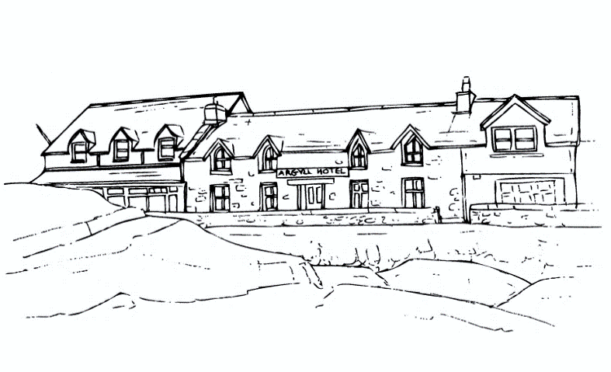

Argyll Hotel, Isle of Iona

Salt and Light: A Celtic Christian Retreat hosted by Kenneth Steven and Kristina Hayward
A programme spanning 5 days and 6 nights, 4th-10th April 2024
After many years of “Salt and Light” being held in October, in 2024 it will take place instead in April – for those who have attended the retreat before, it will be an opportunity to experience Iona at a different time of year.
Kenneth Steven and Kristina Hayward are both Christians who live on the coast of Argyll – not many miles as the crow flies from the island of Iona. They know and love this country of Scotland and, for Kenneth, Iona has been at the very heart of his writing through the years. The retreat seeks to offer a deep sense of what lies at the island’s heart. Kristina and Kenneth will re-create something of the story of Iona’s early days and seek to convey a sense of those Celtic Christian beginnings.
Through creative practice and walks to discover Iona’s secret corners, the goal will be to re-experience something of the simplicity and beauty of Celtic Christian practice and allow its inspiration to re-kindle and challenge our faith today.
The group will gather in time for dinner on the first date of the retreat and disperse after breakfast on the last date. It’s imperative to bring warm and waterproof clothing and sturdy walking shoes/boots. In addition, a notebook and some form of camera, crayons and paints would be useful. You might also want to bring favourite meditations and poems.
We are offering this retreat for an inclusive fee of £1,200 (price based upon a single participant occupying a garden view single room; single occupancy of small doubles priced from £1,200 and double rooms available from £1,200 per person – includes full board accommodation and course fee). Interested participants should contact Kenneth and Kristina in the first instance on info@kennethsteven.co.uk. Once you’ve reserved a space on the course with them, please contact reception on 01681 700334 or by e-mail to reception@argyllhoteliona.co.uk to book with us.

